Genetic Game of Life

John McCaskill, Norman Packard

This work was started as part of an EON Seed Grant, where the main focus was using lablets and dock hardware to explore a hybrid electrochemical-electronic system that has the potential of evolution, with information represented in electronic genomes stored in spatially local lablets or dock sites.

We report on theoretical progress with understanding the relation between complex “life” processes capable of universal computation (as in Conway’s Game of Life) and evolution via genomic extension. In a way, this model captures some features of the relation between complex chemistry and electronic genomes. It is of interest for two main reasons: (i) the universal computation in Conway’s Game of Life suffers from the drawback that in known random ensembles of initial conditions, long lasting computationally complex globally communicating computations are exceedingly rare: normally the patterns degenerate into isolated patches with rather restricted dynamical behaviours (ii) in contrast with evolutionary models, the GoL suffers from extreme sensitivity to single bit changes and hence lack of robust behaviour.

Thus, in thinking about the relation of electronic genomes to complex chemical functionality and computation in lablets, the following extension of the Game of Life occurred to John S. McCaskill and Norman H. Packard : we call it genelife or the Genetic Game of Life. In short, Conways’ game of life is extended to an evolving dynamical system by associating a genome in the form of a binary string to each “live” site and using it to modulate the rules of the cellular automaton. For the simulation, a simple Python/Matplotlib implementation of Conway's Game of Life (GoL) was extended to include the influence of genes proliferating as directed by the game and influencing the random innovations in the game, allowing long term interesting activity and evolution in the GoL.

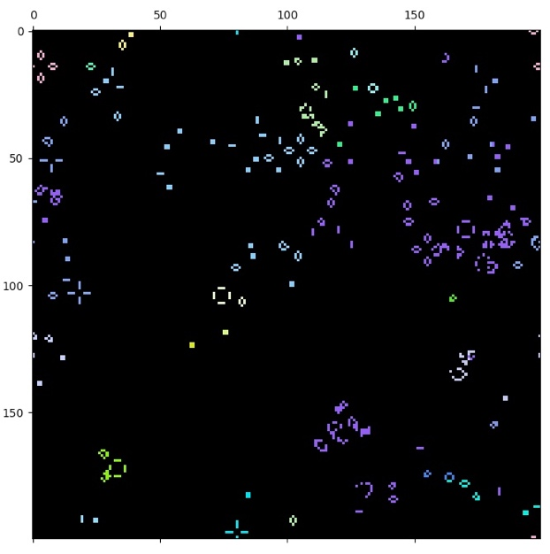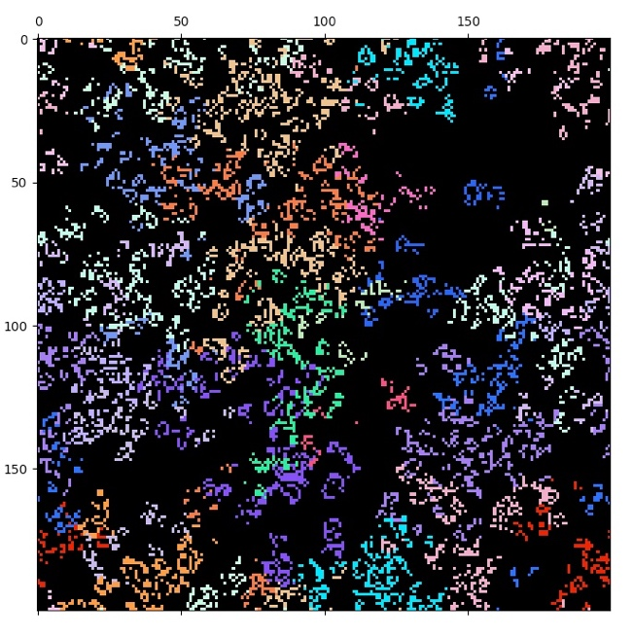

**Fig. 12 Genetic Game of Life.** The two panes compare the results of the normal game of life for random initial conditions with the genetic game of life introduced in this project. Left: The standard behaviour of the game of life after moderate times (2560 updates) is mostly reduced to local remnants with simple periodic behaviours. Right: The genetic game of life gives rise to global and complex dynamics in which many species (genes) persist and participate. The colours are black for empty (0) states and random colours for the different genes of live states (1).

Rules of the Genetic Game of Life

1. Individuals (with a binary string gene) are associated only with "live" / “on” or “1” sites.
2. Individuals die and genes destroyed when a site “dies” i.e. is set to “empty” / “off” / “0”.
3. Individuals are “born”/ “come alive” to a central empty site when 3 individuals are in the neighbourhood. This rule, consistent with Conway’s rules, may be overridden below. Here and below, birth is by replication from one of these neighbouring individuals by point mutation (or later optionally with recombination, from two or three). The parent(s) for replication with mutation are chosen randomly from the neighbours.
4. Conway's rule is occasionally overridden stochastically for empty sites with 2 or 3 live neighbours. The probability of rule override p = p0 e-αd is low and decays exponentially with increasing hamming distance d of neighbours (cumulative for 3 neighbours).

The opposite behaviour to GoL occurs during rule override:

* In the case of three live neighbours, the central site remains dead with no replication.
* In the case of two live neighbours, the central site comes alive by replication.

For p0 = 0, the occupied cells follow exactly Conway's game of life, and the genes execute neutral selection from an initially random population. For p0 >0, the probability of departures from Conway's rules are greatest with monoclonal neighbours and become negligible if neighbours are distantly related. In this way, a feedback is created between pattern stagnation and innovation. With the current parameters, no degeneration to a set of non-communicating local structures occurs The model is likely to be more interesting still with recombination than point mutation, NYI.

Investigations of the model are still underway, but at this early stage we can report that the interaction between the genes and the Game of Life can simultaneously stabilize interesting global dynamics in the Game of Life and spatial ecologies of interacting genes. To see this, we introduce random colors for different genes and display the Genetic Game of Life as coloured versus black. In the case of p0 = 0, the normal statistically uninteresting fate of the game of life is observed with mostly periodic isolated local structures. In the case of p0 = 0.1 and α=1, genes of length 63 bits, mutation rate of 0.3 per gene, and a periodic lattice of size 200x200, the marked difference in persistent long term dynamically complex behaviour is apparent in fig. 12.

Further statistical studies of this model, and related variants including recombination and other modes of overriding specific rules in Conway’s game of life probabilistically are planned. In particular, model variants in which either the rule to be modified or the probability is encoded in the genome are also of interest.